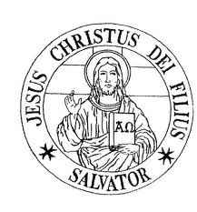
SALVATORIAN FATHERS
23 Crestmont Rd.
Verona, NJ 07044
PHONE: 973 746-8770; 973 433-7626 / E-mail: veronasds@gmail.com
___________________________________________________________________
Holy Masses – Individual
(Free Donation, If you can no less then $15.00)
1 | Intention: | $
2 |  | $
3 |  | $
Gregorian Masses
30 daily Masses for one deceased person
(Free Donation for 30 Masses, if you can no less than $450)
1 | Intention: | $
2 |  | $
The enrolment in Perpetual Mass Association
(for living or deceased)
One person: $30; Family (parents and children): $100
1 | Intention: | $
2 |  | $
Other donations
(Church, seminary, missions, …. – Please specify)
1 |  | $
 |  | $

Donated by:
First and Last Name
Address:

Phone/ E-mail

